UNDER EMBARGO UNTIL 00:01 ON TUESDAY 2nd NOVEMBER 2021

JERWOOD ARTS ANNOUNCES THE
JERWOOD COMPTON POETRY FELLOWS 2021

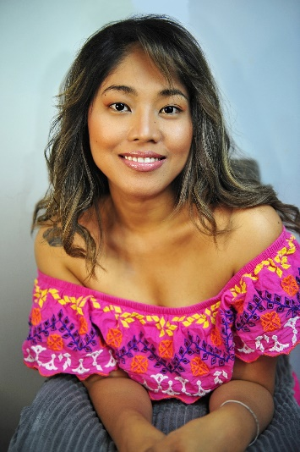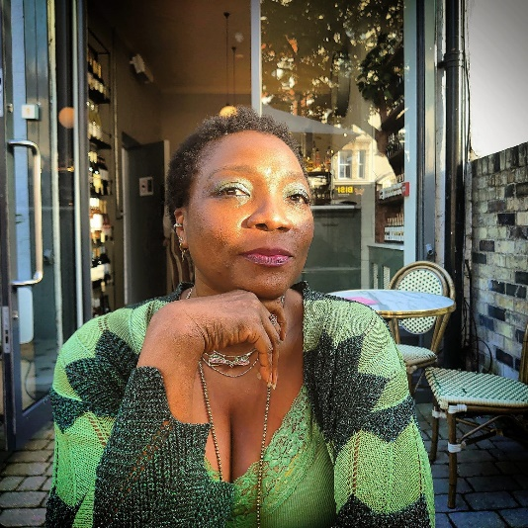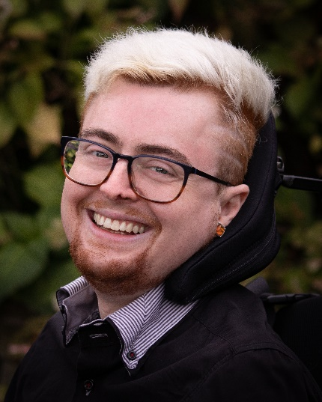
Romalyn Ante, Dzifa Benson, and Jamie Hale (credit Mat Chat)

ROMALYN ANTE | DZIFA BENSON | JAMIE HALE

UNDER EMBARGO UNTIL 00.01 ON 2ND NOVEMBER 2021: Three of the UK’s most exciting poets Romalyn Ante, Dzifa Benson, and Jamie Hale have been selected as the Jerwood Compton Poetry Fellows for 2020/21.

Each poet receives £15,000 and is given a year of critical support and mentoring. Turning the idea of an arts prize on its head, the Jerwood Compton Poetry Fellowship provides each poet with the time and space to focus on their craft and fulfil their potential with no expectation that they produce a particular work or outcome.

Recognising the power of potential, the Jerwood Compton Poetry Fellowship’s approach to funding advocates for a change in art funding practice in the UK, providing opportunities outside commercial pressures for artistic growth and new ideas to flourish. The Fellowship provides financial support towards the development of under-supported and diverse artistic practices across the UK, with a focus on the pursuit of artistic experimentation and the space for artists to thrive.

This alternative approach to recognising and rewarding outstanding poets, is now in its third and final edition. Previous recipients are: Raymond Antrobus, Jane Commane and Jackie Hagan (2017-18 Jerwood Compton Poetry Fellows) and Hafsah Aneela Bashir, Anthony Joseph and Yomi Ṣode (2019-20 Jerwood Compton Poetry Fellows).

Romalyn Ante, Dzifa Benson, and Jamie Hale illustrate how diverse and exciting poetry has become in the 21st century. Through activism, visual arts, theatre, and drawing from their personal experiences/circumstances, the three poets express their practice through a multitude of ways, opening poetry up to a wide range of audiences. Each poet has produced outstanding work to date and have demonstrated enormous, unselfish generosity towards other poets, giving far more than they have received particularly during the pandemic. They have been selected for the potential they display at this critical point in their individual careers, when the support provided from the Fellowship will make the most difference.

Alongside the freely given grant of £15,000, the three Fellows will each receive mentoring from the programme’s manager Dr Nathalie Teitler FRSA and access to experts drawn from the poetry world and beyond. Nathalie has run literature programmes promoting diversity in the UK for over 20 years, founding the first national mentoring and translation programmes for writers living in exile. She is the Director of The Complete Works – a national development programme that helped to raise the number of Black and Asian poets published by major presses.

Romalyn Ante is an award-winning Filipino-born, Wolverhampton-based poet, translator, editor and essayist. She is co-founding editor of harana poetry, an online magazine for poets writing in English as a second or parallel language, and her accolades include the Poetry London Prize, Manchester Poetry Prize, Society of Author's Foundation Award, Developing Your Creative Practice, Creative Future Literary Award, amongst others. Apart from being a writer, she also works full-time as a nurse practitioner, specializing in providing different psychotherapeutic treatments.

Dzifa Benson is a multi-disciplinary artist whose work intersects science, art, the body and ritual, which she explores through poetry, prose, theatre-making, performance, essays and criticism. She has performed nationally and internationally for Tate Britain, the Courtauld Institute of Art, BBC Africa Beyond and more, and she abridged the National Youth Theatre’s 2021 production of Othello in collaboration with Olivier award-winning director Miranda Cromwell.

Jamie Hale is a poet, script/screenwriter and essayist based in London, whose work often explores the disabled body, nature, and mortality. Their pamphlet, Shield - about disability, treatment prioritisation, and the COVID-19 pandemic was published in January 2020. Their solo poetry show, NOT DYING, was performed at the Lyric Hammersmith and Barbican Centre in 2019, and the filmed version has screened nationally and internationally since. Jamie is also the founder of CRIPtic Arts, an organisation showcasing and developing work by and for d/Deaf and disabled creatives.

Jon Opie, Deputy Director, Jerwood Arts: The Jerwood Compton Poetry Fellowships is a special programme, which over the last four years has charted significant changes in the poetry world as begins to embrace the diversity of voices, experience and histories it encompasses. Past Fellows, and now the ones we have announced today, exemplify some of the multitudes of forms and languages that makes poetry an essential part of this country’s life, inseparable from mainstream media, powerfully articulating lived-experiences and enhancing other art forms. I am hugely looking forward to working with Romalyn, Dzfia and Jamie over the coming year. Their talents are unique, and yet they share a generosity and sense of responsibility towards other poets and their communities. I have no doubt their Fellowships will be profound for them and for others around them.

Sarah Crown, Director of Literature, Arts Council England: The Jerwood Compton Poetry Fellowship continues to champion change in art funding practice in the UK as fearlessly as it has done for the last four years. Providing mentoring, financial support and, most importantly, time and space for under-represented poets to experiment and hone their craft - without the external pressures of meeting a particular outcome - nurtures creativity and enriches the sector as a whole.

The selectors have had the tough task of choosing three recipients from what was yet again an extremely strong set of nominees. Romalyn, Dzifa and Jamie join a long line of talented Fellows, and I am excited to see how they flourish over the coming year.

The three recipients were selected from a strong field of nominees by award-winning poet and writer Joelle Taylor; writer, performer, and facilitator Yomi Ṣode (Jerwood Compton Poetry fellow 2019); and award-winning poet Pascale Petit.

Nominations were made by a pool of over 200 specialists nationally including poets, publishers, editors, literary development agencies, artists, funders and festival organisers.

Selector Joelle Taylor said: ”The task of selecting only three Fellows from a longlist of 86 poets was a painful process. Each of the poets we saw were of an international standard, committed to their practice and the changes they wish to see in their work. We made decisions based not only who was ‘best’ but on who it felt most essential to support. The three Fellows we chose are at an urgent moment in their careers. They stand at a crossroads within their art, compelled to make substantial changes, to forge new narratives, to develop in a way that would not be possible without support from Jerwood Compton Poetry Fellowships.”

The poets now join the six previous Jerwood Compton Poetry Fellows – Raymond Antrobus, Jane Commane, Jackie Hagan, Yomi Ṣode, Hafsah Aneela Bashir and Anthony Joseph – who have shown how transformative a supported year can be.

Without setting limits or expectations, the Fellowship has enabled the careers of previous Fellows to flourish. Each Fellow has significantly developed their practice, and themselves, through the support of the Jerwood Compton Poetry Fellowships.

Fellow Raymond Antrobus has gone on to win the Ted Hughes Award, be the London Book Fair Poet of The Fair, and be shortlisted for the Forward Prize for Best First Collection and the Griffin Poetry Prize, amongst other achievements. In 2019 he became the first ever poet to be awarded the Rathbone Folio Prize for the best work of literature in any genre.

Jane Commane launched her first poetry collection, Assembly Lines at the Verve Festival in 2018, published by Bloodaxe. She also launched How to be a Poet: A 21st Century Guide to Writing Well, which ranked among the top five writing guides on Amazon. She is currently working on her second poetry collection, working title Municipal.

Jackie Hagan was one of five writers selected by Hat Trick Productions for its Your Voice, Your Story development scheme in partnership with Channel 4. In 2018, her one woman show, This is Not a Safe Place, showcased at the Hebden Bridge Festival and at the Unlimited Festival, Southbank Centre.

Fellow Yomi Ṣode has toured his acclaimed one-man show COAT to sold-out audiences. In 2020 his libretto Remnants, written in collaboration with award-winning composer James B. Wilson and Chineke! Orchestra was lauded by BBC Radio 3 and The Guardian. He founded BoxedIn and The Daddy Diaries – an online blog platform for Fathers & guardians. Yomi’s debut collection is scheduled for publication by Penguin in Spring 2022.

Fellow Hafsah Aneela Bashir was commissioned to write her play Cuts Of The Cloth for PUSH Festival 2019. Her debut poetry collection The Celox And The Clot was published by Burning Eye Books. During lockdown she founded the Poetry Health Service, a digital service providing free poetry panaceas by the people for the people.

Fellow Anthony Joseph was shortlisted for the Republic of Consciousness Prize, the Royal Society of Literature’s Encore Award, and long listed for the OCM Bocas Prize for Caribbean Literature for his novel Kitch. As a musician, he has released seven critically acclaimed albums, and in 2020 he received a Paul Hamlyn Foundation Composers Award.

-Ends-

For all press enquiries, please contact:
Tory Lyne-Pirkis tory.lyne-pirkis@midaspr.co.uk | 07765503053
Anna Zanetti anna.zanetti@midaspr.co.uk | 07583127515

Press images are available here

Jerwood Compton Poetry Fellowships
The Jerwood Compton Poetry Fellowships are a six-year initiative supporting poets in the UK. The programme runs biennially for three editions between 2017 and 2022, creating a total of nine Fellows. Each receives a bursary of £15,000 and mentoring support. The Fellowships invest in the process and practice of making poetry, with no expectations of published work or performed events as a result of the award, and support individuals whose practice encompasses poetry in the broadest artistic sense. Poets are matched with a core mentor and have further access to a range of advisers and ‘critical friends’ to support their developing practice.

Project credit:
The Jerwood Compton Fellowships are designed and managed by Jerwood Arts, with support from Arts Council England including funds from the Joseph Compton bequest.

Jerwood Arts is the leading independent funder dedicated to supporting early-career UK artists, curators and producers to develop and thrive. We enable transformative opportunities for individuals across art forms, supporting imaginative awards, fellowships, programmes, commissions and collaborations. We present new work and bring people from across the arts together in the galleries at Jerwood Space, London, as well as online and across the UK.

www.jerwoodarts.org

Arts Council England is the national development body for arts and culture across England, working to enrich people’s lives. We support a range of activities across the arts, museums and libraries – from theatre to visual art, reading to dance, music to literature, and crafts to collections. Great art and culture inspires us, brings us together and teaches us about ourselves and the world around us. In short, it makes life better. Between 2018 and 2022, we will invest £1.45 billion of public money from government and an estimated £860 million from the National Lottery to help create these experiences for as many people as possible across the country.

www.artscouncil.org.uk

