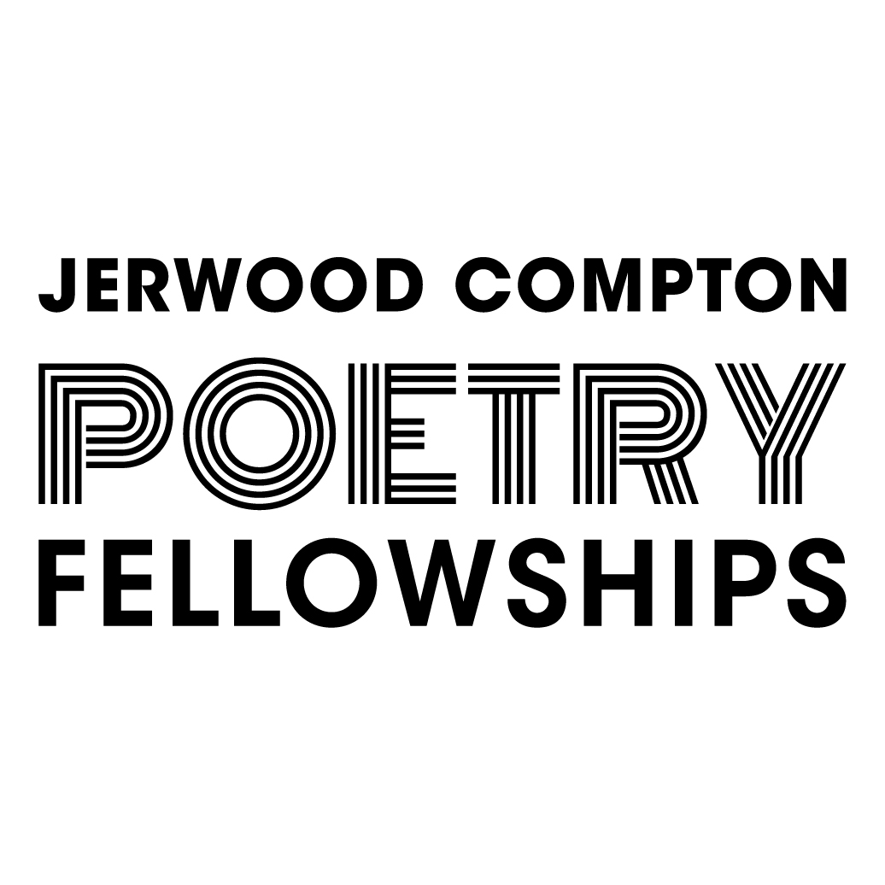

Jerwood Compton Poetry Fellowships
Application Form

The personal data you give us here will be used by Jerwood Arts staff, paid independent assessors and members of the selection panel. It will not be passed on to anyone else. Poets will only be contacted regarding their application for a Jerwood Compton Poetry Fellowship. If you want to be removed from our database you can do so by calling 020 7261 0279 or emailing Jon Opie.
You have the right to contact the Information Commissioner’s Office should you wish to complain about how information has been handled. If you wish to receive information about our activities, events and opportunities, please sign up for the Jerwood Arts newsletter here.

- First Name

- Last Name

- Email Address

- Telephone Number

- Location

We align our area boundaries with Arts Council England.
To find your region please follow this link.

Scotland
Wales
Northern Ireland
North
Midlands
London
South East
South West

- Please indicate whether you would like to send a written or film/audio application.
Written Application
Film/Audio Application

Written Application

If you choose to send us a written application, you will be directed to this form. You should answer the following questions within the indicated character counts.
- What poetry form(s) or style(s) best describes your work?

(Text box, 250 characters maximum)

- Statement about your practice
Describe your practice, your interests and some key projects you have been working on in the past six months.
(Text box, 1250 characters maximum)

- How would you use a Jerwood Compton Poetry Fellowship to develop your practice?
There is no expectation of publication or performance as a result of the Fellowships. Here we would like to know how you want to grow creatively and professionally with the freedom the bursary offers and the expert support of mentors.
(Text box, 1750 characters maximum)

- What three things do you hope to achieve as a result of your Fellowship?
Think about what you would like to accomplish during the supported-year that would significantly help your career and craft.
(Text box, 250 characters maximum)

(Text box, 250 characters maximum)

(Text box, 250 characters maximum)

Film/Audio Application

If you choose to send us a film/audio application, you will be directed to this entry form.
You should send us a recording that complies with the below guidelines and covers all the information in the written form above.
- Please ensure your recording is no more than five minutes long.
- You may link to a third party website such as Google Drive, Soundcloud, Vimeo or Dropbox.
- There will be an option to provide a password if necessary.

Examples of your Work
Provide examples of your work that best support your application.
Please either:
- Upload a pdf document containing between 3 and 10 poems.

Or

- Provide up to three links to filmed or audio work totalling no more than 10 minutes in length.
- You may link to a third party website such as Google Drive, Soundcloud, Vimeo or Dropbox.
- There will be an option to provide a password if necessary.

You must select the SUBMIT button at the end of the application, including the Monitoring Information, or it will not reach us.
Once you have sent us your application, you will receive a confirmation from email from Nathalie Teitler. If you do not receive this email, please first check your junk mail and then contact Sarah to find out if we’ve received it safely.

